TS-SF-DXX42-40D
4.25Gbps Single Mode DWDM SFP Transceiver
PRODUCT FEATURES
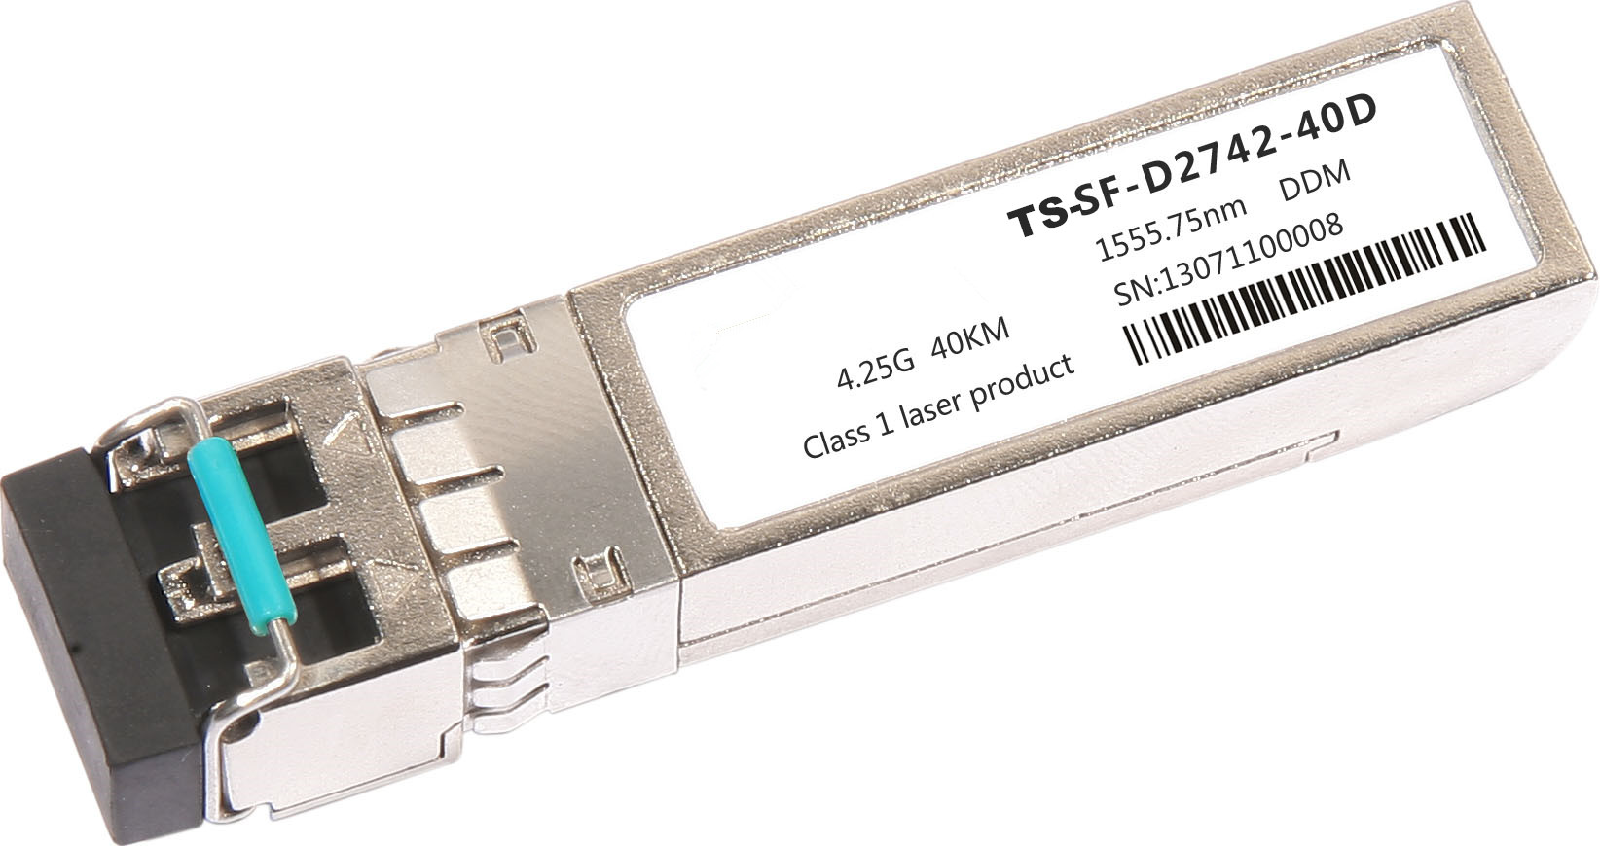
- Transceiver unit with independent
DWDM DFB Laser diode transmitter
PIN receiver
- Compliant with DWDM SFP MSA
- SFF-8472 with duplex LC receptacle
- Hot-pluggable
- Metal enclosure for lower EMI
- 3.3V Single power supply
- 100GHz ITU Grid, C Band
- Wavelength controlled within ± 0.1nm over life and temperature
- Digital diagnostic monitoring
- 40 km with 9/125 µm single mode fiber (SMF) of maximum interconnect distances
- Case operating temperature：0°C to +70°C

APPLICATIONS
- C Band DWDM networks
- SONET/SDH networks
- Fiber channel
- Gigabit Ethernet

PRODUCT DESCRIPTION
TS-SF-DXX42-40D Small Form Factor Pluggable (SFP) transceivers are compatible with the Small Form Factor Pluggable Multi-Sourcing Agreement (MSA) and SFF-8472. The transceiver consists of five sections: the LD driver, the limiting amplifier, the digital diagnostic monitor, the DFB laser and the PIN-TIA.The module data link up to 40KM in 9/125um single mode fiber. It offers a simple and convenient way to interface PCBs to single mode fiber optic cables in Dense Wavelength Division Multiplexing (DWDM) applications. It is a high performance, cost effective module for serial optical data communication applications。

The optical output can be disabled by a TTL logic high-level input of Tx Disable, and the system also can disable the module via I2C. Tx Fault is provided to indicate that degradation of the laser. Loss of signal (LOS) output is provided to indicate the loss of an input optical signal of receiver or the link status with partner. The system can also get the LOS (or Link)/Disable/Fault information via I2C register access.

- Pin Descriptions
Pin | Symbol | Name/Description | NOTE
1 | VEET | Transmitter Ground (Common with Receiver Ground) | 1
2 | TFAULT | Transmitter Fault.
3 | TDIS | Transmitter Disable. Laser output disabled on high or open. | 2
4 | MOD_DEF(2) | Module Definition 2. Data line for Serial ID. | 3
5 | MOD_DEF(1) | Module Definition 1. Clock line for Serial ID. | 3
6 | MOD_DEF(0) | Module Definition 0. Grounded within the module. | 3
7 | Rate Select | No connection required | 4
8 | LOS | Loss of Signal indication. Logic 0 indicates normal operation. | 5
9 | VEER | Receiver Ground (Common with Transmitter Ground) | 1
10 | VEER | Receiver Ground (Common with Transmitter Ground) | 1
11 | VEER | Receiver Ground (Common with Transmitter Ground) | 1
12 | RD- | Receiver Inverted DATA out. AC Coupled
13 | RD+ | Receiver Non-inverted DATA out. AC Coupled
14 | VEER | Receiver Ground (Common with Transmitter Ground) | 1
15 | VCCR | Receiver Power Supply
16 | VCCT | Transmitter Power Supply
17 | VEET | Transmitter Ground (Common with Receiver Ground) | 1
18 | TD+ | Transmitter Non-Inverted DATA in. AC Coupled.
19 | TD- | Transmitter Inverted DATA in. AC Coupled.
20 | VEET | Transmitter Ground (Common with Receiver Ground) | 1

Notes:
- Circuit ground is internally isolated from chassis ground.
- Laser output disabled on TDIS >2.0V or open, enabled on TDIS <0.8V.
- Should be pulled up with 4.7k - 10kohms on host board to a voltage between 2.0V and 3.6V.MOD_DEF (0) pulls line low to indicate module is plugged in.
- This is an optional input used to control the receiver bandwidth for compatibility with multiple data rates (most likely Fiber Channel 1x and 2x Rates).If implemented, the input will be internally pulled down with > 30kΩ resistor. The input states are:
  - Low (0 – 0.8V): Reduced Bandwidth
  - (>0.8, < 2.0V): Undefined
  - High (2.0 – 3.465V): Full Bandwidth
  - Open: Reduced Bandwidth
- LOS is open collector output should be pulled up with 4.7k - 10kohms on host board to a voltage between 2.0V and 3.6V. Logic 0 indicates normal operation; logic 1 indicates loss of signal.
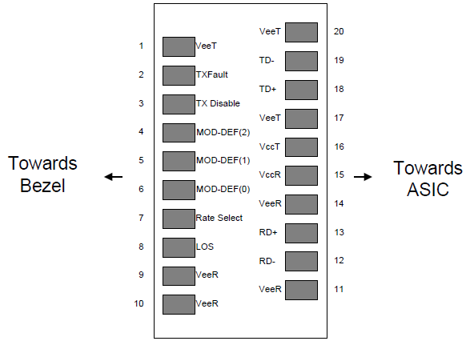
Figure2. Pin out of Connector Block on Host Board

II. Absolute Maximum Ratings
Parameter | Symbol | Min. | Typ. | Max. | Unit | Note
Storage Temperature | Ts | -40 |  | 85 | ºC
Relative Humidity | RH | 5 |  | 95 | %
Power Supply Voltage | VCC | -0.5 |  | 4 | V
Signal Input Voltage |  | -0.3 |  | Vcc+0.3 | V
Receiver Damage Threshold |  | +5 |  |  | dBm
III. Recommended Operating Conditions
Parameter | Symbol | Min. | Typ. | Max. | Unit | Note
Case Operating Temperature | Tcase | 0 |  | 70 | ºC
Power Supply Voltage | VCC | 3.13 | 3.3 | 3.47 | V
Power Supply Current | ICC |  |  | 500 | mA
Power Supply Noise Rejection |  |  |  | 100 | mVp-p | 100Hz to 1MHz
Data Rate |  |  | 4250/4250 |  | Mbps | TX Rate/RX Rate
Transmission Distance |  |  |  | 40 | KM
Coupled Fiber | Single mode fiber |  |  |  |  | 9/125um SMF

- Specification of Transmitter
Parameter | Symbol | Min. | Typ. | Max. | Unit | Note
Center Wavelength Spacing |  |  | 100 |  | GHz
Center Wavelength | λ | X-100 | X | X+100 | pm | Note (1)
Average Output Power | POUT | -1 |  | 4 | dBm
Extinction Ratio | ER | 6 |  |  | dB
Side Mode Suppression Ratio | SMSR | 30 |  |  | dB
Spectrum Bandwidth(-20dB) | σ |  |  | 0.3 | nm
Transmitter OFF Output Power | POff |  |  | -45 | dBm
Differential Line Input Impedance | RIN | 90 | 100 | 110 | Ohm
Output Eye Mask | Compliant with ITU recommendation G.957 |  |  |  |  | Note (2)

Note (1): X = specified ITU center wavelength. (To See “Ordering Information”)
Note (2): Transmitter eye mask definition.
x₃-x₂ | 0.2
y₁ | 0.25
y₂ | 0.75
y₃ | 0.25
y₄ | 0.25

V. Specification of Receiver
Parameter | Symbol | Min. | Typ. | Max. | Unit | Note
Input Optical Wavelength | λIN | 1270 |  | 1610 | nm
Receiver Sensitivity | PIN |  |  | -18 | dBm | Note (1)
Input Saturation Power (Overload) | PSAT | -0.5 |  |  | dBm
Los Of Signal Assert | PA |  |  | -19 | dBm
Los Of Signal De-assert | PD | -30 |  |  | dBm | Note (2)
LOS Hysteresis | PA-PD | 0.5 | 2 | 6 | dB

Note (1): Measured with Light source 1550nm, ER=6dB; BER =<10^-12 @PRBS=2^23-1 NRZ
Note (2): When LOS de-asserted, the RX data+/- output is High-level (fixed)
VI. Electrical Interface Characteristics
Parameter | Symbol | Min. | Typ. | Max. | Unit | Note
Transmitter
Total Supply Current | ICC |  |  | A | mA | Note (1)
Transmitter Disable Input-High | VDISH | 2 |  | Vcc+0.3 | V
Transmitter Disable Input-Low | VDISL | 0 |  | 0.8 | V
Transmitter Fault Input-High | VDISL | 2 |  | Vcc+0.3 | V
Transmitter Fault Input-Low | VTxFH | 0 |  | 0.8 | V
Receiver
Total Supply Current | ICC |  |  | B | mA | Note (1)
LOSS Output Voltage-High | VLOSH | 2 |  | Vcc+0.3 | V | LVTTL
LOSS Output Voltage-Low | VLOSL | 0 |  | 0.8 | V | LVTTL

Note (1): A (TX) + B (RX) = 500mA (Not include termination circuit)

VII. Digital Diagnostic Functions
TS-SF-DXX42-40D transceivers support the 2-wire serial communication protocol as defined in the SFP MSA. It is very closely related to the E2PROM defined in the GBIC standard, with the same electrical specifications.

The standard SFP serial ID provides access to identification information that describes the transceiver’s capabilities, standard interfaces, manufacturer, and other information.

Additionally, SFP transceivers provide a unique enhanced digital diagnostic monitoring interface, which allows real-time access to device operating parameters such as transceiver temperature, laser bias current, transmitted optical power, received optical power and transceiver supply voltage .It also defines a sophisticated system of alarm and warning flags, which alerts end-users when particular operating parameters are outside of a factory set normal range.

The SFP MSA defines a 256-byte memory map in E2PROM that is accessible over a 2-wire serial interface at the 8 bit address 1010000X (A0h). The digital diagnostic monitoring interface makes use of the 8 bit address 1010001X (A2h), so the originally defined serial ID memory map remains unchanged. The interface is identical to, and is thus fully backward compatible with both the GBIC Specification and the SFP Multi Source Agreement.

The operating and diagnostics information is monitored and reported by a Digital Diagnostics Transceiver Controller (DDTC) inside the transceiver, which is accessed through a 2-wire serial interface. When the serial protocol is activated, the serial clock signal (SCL, Mod Def 1) is generated by the host. The positive edge clocks data into the SFP transceiver into those segments of the E2PROM that are not write-protected. The negative edge clocks data from the SFP transceiver. The serial data signal (SDA, Mod Def 2) is bi-directional for serial data transfer. The host uses SDA in conjunction with SCL to mark the start and end of serial protocol activation. The memories are organized as a series of 8-bit data words that can be addressed individually or sequentially.

Digital diagnostics for the TS-SF-DXX42-40D are internally calibrated by default.。

VIII. Recommend Circuit Schematic
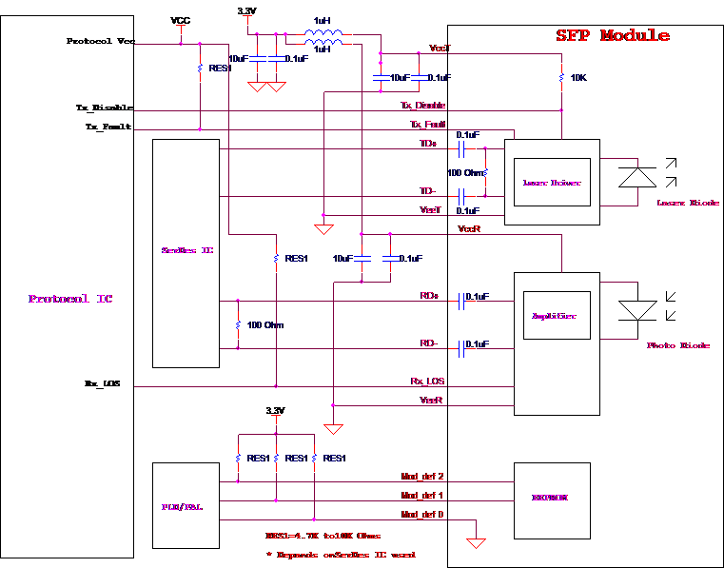
IX. Mechanical Specifications (Unit: mm)

- Ordering Information
Code | Frequency (THz) | Center Wavelength(nm) | Code | Frequency (THz) | Center Wavelength(nm)
C17 | 191.7 | 1563.86 | C40 | 194.0 | 1545.32
C18 | 191.8 | 1563.05 | C41 | 194.1 | 1544.53
C19 | 191.9 | 1562.23 | C42 | 194.2 | 1543.73
C20 | 192.0 | 1561.42 | C43 | 194.3 | 1542.94
C21 | 192.1 | 1560.61 | C44 | 194.4 | 1542.14
C22 | 192.2 | 1559.79 | C45 | 194.5 | 1541.35
C23 | 192.3 | 1558.98 | C46 | 194.6 | 1540.56
C24 | 192.4 | 1558.17 | C47 | 194.7 | 1539.77
C25 | 192.5 | 1557.36 | C48 | 194.8 | 1538.98
C26 | 192.6 | 1556.55 | C49 | 194.9 | 1538.19
C27 | 192.7 | 1555.75 | C50 | 195.0 | 1537.40
C28 | 192.8 | 1554.94 | C51 | 195.1 | 1536.61
C29 | 192.9 | 1554.13 | C52 | 195.2 | 1535.82
C30 | 193.0 | 1553.33 | C53 | 195.3 | 1535.04
C31 | 193.1 | 1552.52 | C54 | 195.4 | 1534.25
C32 | 193.2 | 1551.72 | C55 | 195.5 | 1533.47
C33 | 193.3 | 1550.92 | C56 | 195.6 | 1532.68
C34 | 193.4 | 1550.12 | C57 | 195.7 | 1531.90
C35 | 193.5 | 1549.32 | C58 | 195.8 | 1531.12
C36 | 193.6 | 1548.51 | C59 | 195.9 | 1530.33
C37 | 193.7 | 1547.72 | C60 | 196.0 | 1529.55
C38 | 193.8 | 1546.92 | C61 | 196.1 | 1528.77
C39 | 193.9 | 1546.12

Appendix A. Document Revision
Version No. | Date | Description
Preliminary | 2014-4-16 | Preliminary datasheet

